HW-484 Magnetic Switch Module (Reed Switch)
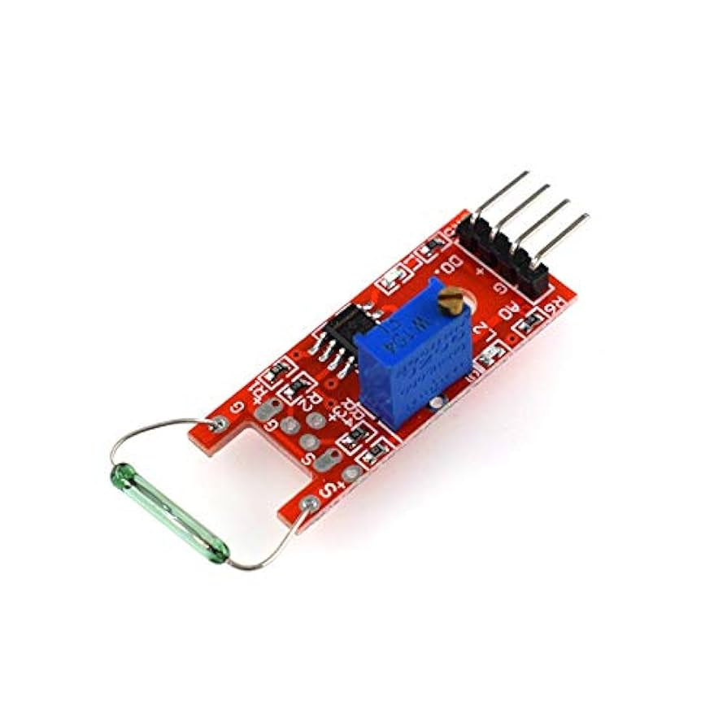

This sensor detects the presence of a magnet. When a magnet comes near the glass-encased reed switch on the module, the contacts inside close, sending a signal. It’s often used for detecting door open/close, security systems, or robot triggers.

Pin Description:
Pin | Function
VCC | Power (3.3V/5V)
GND | Ground
DO | Digital Output

Sensor type: Dry Reed Switch
Power: 3.3V to 5V
Output:
- DO (Digital Output): Goes LOW when magnet is near
- AO (Analog Output): Not always present, depends on the version
LED indicator: Lights up when the switch is triggered

